

Asset Practice Questions: Science

**1. Kamran tried to grow two similar plants, one inside a dark room and the other in the hot Sun, as shown in the figure. He gave the same amount of water to these plants daily. What was he trying to check?**

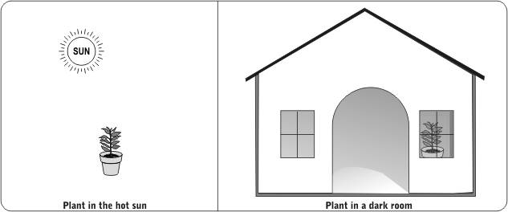

**A.** Do plants need water to grow?

**B.** Do plants need light to grow?

**C.** Do plants need soil to grow?

**D.** Do plants need air to grow?

**2. Raman is blindfolded and he has to identify an object just by hitting it with a metal spoon. He identifies one of them by its ringing sound. Which one is it?**

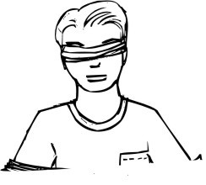

**A.** A brick

**B.** A steel plate

**C.** A book

**D.** A wooden block

**3.** 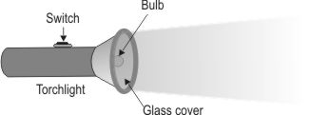

**Akila's torchlight did not light up when she switched it ON. One of the things she should check is .**

**A.** if the glass cover on the torch is in place

**B.** if the torch is made of plastic

**C.** the date on which the torch was bought

**D.** if the batteries are fitted in the torch

**4. Anu takes equal amounts of rice in two vessels and pours the same amount of water in each of them.**

**She then puts them both on the stove for the rice to cook. She wants to check whether rice cooks** **faster in salt water or in plain water. What else should she do to check this before turning the stove on?**

**A.** Mix salt in both the vessels.

**B.** Mix salt in only one of the vessels.

**C.** Add more water to both the vessels.

**D.** Add more water to only one of the vessels.

**5. Shashank wants to play cricket in the playground. He tries to push the stumps into the ground, but the ground is very hard and the stumps do not go in.**

**What can he try to do to make the stumps go in easily?**

**A.** Rub the stumps with sand to make them rough.

**B.** Apply oil on the stumps to make the surface smooth.

**C.** Blow air on that part of the ground to make the soil loose.

**D.** Pour a little water on that part of the ground to make the soil soft.

**6. Meera looked through the glass window of her house in the afternoon. She could see everything through it. She thought it was because light passes through it easily. Which other object would do the same?**

**A.** A mirror

**B.** A polished plate

**C.** A wooden sheet

**D.** A pair of spectacles

**7. Prem finds that his friend's heart is beating very fast. What could his friend have been doing just before?**

**A.** Running up the stairs **B.** Reading a story book **C.** Eating an ice cream

**D.** Watering his plants

**8. On a hot summer day, Radha keeps the same amount of water in the four containers in the kitchen.**

**After a few hours, water in which container will be coldest?**

**A.** A plastic bottle

**B.** A steel vessel

**C.** A mud pot

**D.** A glass bottle

**9. The cover of a gutter in a crowded street was removed and the gutter was left open. What can one do to make sure that nobody falls in?**

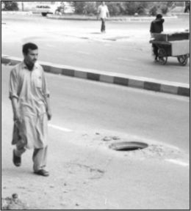

**A.** Place some big stones around it.

**B.** Cover it with big leaves and newspapers.

**C.** Tell a passerby about it and leave it as it is.

**D.** Announce this news over the radio.

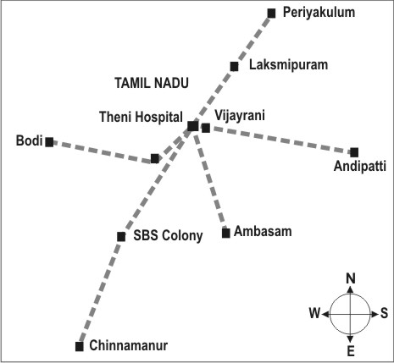**10.**

**Which of these places is located to the North of Theni Hospital?**

**A.** Andipatti

**B.** Ambasam

**C.** Chinnamanur

**D.** Laksmipuram

**11. Look carefully at the map given below.**

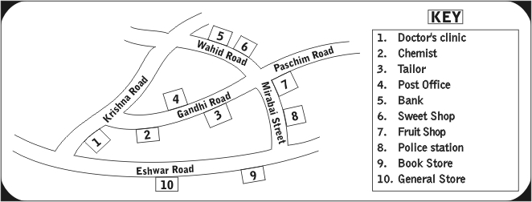

**Which two of these are nearest to each other?**

**A.** Bank and Sweet shop

**B.** Post office and General store

**C.** Fruits shop and Police station

**D.** Doctor's clinic and Chemist

**12. Tina went up to the terrace and noted down all the things she saw in the sky. She saw the Moon, the clouds, birds, the Sun and an aeroplane. She is looking at the .**

**A.** night sky, because we can see the Moon only in the night

**B.** night sky, because birds and aeroplanes fly only in the night

**C.** day sky, because we see clouds only during the day, and not at night

**D.** day sky, because sometimes we see the Sun and the Moon, during the day